MICRO PROJECT REPORT

Title
Application of Brute-Force and Divide-and-Conquer Approaches to Solve Computational Problems such as Assignment Tasks and Large Integer Multiplication in Scientific Computing

Abstract
Scientific computing requires efficient algorithms to solve computationally intensive problems. This micro project presents the implementation and performance analysis of two fundamental algorithmic paradigms: Brute Force and Divide-and-Conquer. The Assignment Problem is solved using the Brute Force technique by examining all possible assignments and selecting the minimum-cost solution. Large Integer Multiplication is implemented using the Karatsuba algorithm, which applies the Divide-and-Conquer paradigm to reduce the number of multiplication operations. The algorithms are implemented using Python and Streamlit to provide an interactive graphical interface. Experimental results demonstrate that the Divide-and-Conquer approach significantly reduces execution time for large inputs compared to conventional multiplication, while Brute Force provides an exact solution for small assignment problems.

Keywords
Brute Force, Divide and Conquer, Assignment Problem, Karatsuba Algorithm, Scientific Computing, Streamlit, Python, Computational Complexity.

Chapter 1: Introduction
Algorithms are essential tools in scientific computing for solving complex mathematical and engineering problems efficiently. Different algorithmic paradigms are used depending on the problem characteristics.
Brute Force is a straightforward approach that systematically examines every possible solution and selects the best one. Although it guarantees an optimal solution, its computational cost increases exponentially with problem size.
Divide-and-Conquer is an efficient design paradigm that divides a problem into smaller subproblems, solves them recursively, and combines the solutions. Karatsuba’s multiplication algorithm is a classical example that improves multiplication complexity.
This project implements:
- Assignment Problem using Brute Force.
- Large Integer Multiplication using Karatsuba Algorithm.
- Interactive visualization using Streamlit.

Chapter 2: Literature Review

Study 1
Cormen et al. introduced Brute Force and Divide-and-Conquer paradigms in algorithm design. The authors demonstrated that Divide-and-Conquer algorithms such as Merge Sort and Karatsuba Multiplication provide better asymptotic complexity than naive approaches.

Study 2
Aho, Hopcroft, and Ullman discussed exhaustive search techniques and showed that Brute Force guarantees optimality but is practical only for small problem sizes.

Study 3
Karatsuba proposed an integer multiplication algorithm in 1962 that reduced multiplication complexity from
T(n)=O(n²)
to
T(n)=O(n^1.585)
using recursive decomposition.

Research Gap
Although these algorithms are theoretically well studied, there is a need for an interactive educational tool that compares their performance visually and experimentally.

Chapter 3: Problem Statement
Scientific applications often require:
- Finding the optimal assignment of resources to tasks.
- Multiplying extremely large integers efficiently.
Traditional methods become inefficient as input size increases.
Therefore, efficient algorithmic paradigms must be investigated and implemented to improve performance.

Chapter 4: Objectives
The objectives of this project are:
- Implement Brute Force algorithm for Assignment Problem.
- Implement Karatsuba Multiplication using Divide-and-Conquer.
- Compare their computational complexity.
- Develop a Streamlit-based graphical interface.
- Evaluate performance using execution time.

Chapter 5: Proposed Methodology
The project consists of two modules.

Module 1

Assignment Problem
Input:
- Cost Matrix
Process:
- Generate all permutations.
- Compute total cost.
- Select minimum cost assignment.
Output:
- Optimal assignment
- Minimum cost

Module 2

Karatsuba Multiplication
Input:
- Two large integers
Process:
- Divide numbers into high and low parts.
- Recursively compute:
z0 = low_x × low_y
z1 = (high_x + low_x)(high_y + low_y)
z2 = high_x × high_y
- Combine results.
Output:
- Product of large integers

Chapter 6: Algorithms

Algorithm 1: Brute Force Assignment
Step 1:
Read cost matrix.
Step 2:
Generate all permutations of jobs.
Step 3:
For each permutation:
- Compute total cost.
Step 4:
Store minimum cost.
Step 5:
Display optimal assignment.

Algorithm 2: Karatsuba Multiplication
Step 1:
If x or y has one digit:
Return x*y.
Step 2:
Divide x and y into:
high and low parts.
Step 3:
Recursively compute:
z0
z1
z2
Step 4:
Combine:
xy=z2×10^{(2m)+(z1−z2−z0)×10}m+z0
Step 5:
Return product.

Chapter 7: Python Implementation

Brute Force Assignment
import itertools
def assignment_bruteforce(cost_matrix):
n = len(cost_matrix)
min_cost = float('inf')
best_assignment = None
for perm in itertools.permutations(range(n)):
cost = sum(cost_matrix[i][perm[i]]
for i in range(n))
if cost < min_cost:
min_cost = cost
best_assignment = perm
return best_assignment, min_cost
cost_matrix = [
[9,2,7,8],
[6,4,3,7],
[5,8,1,8],
[7,6,9,4]
]
assignment,cost=assignment_bruteforce(cost_matrix)
print(assignment)
print(cost)

Karatsuba Multiplication
def karatsuba(x,y):
if x<10 or y<10:
return x*y
m=min(len(str(x)),
len(str(y)))//2
high_x,low_x=divmod(x,10**m)
high_y,low_y=divmod(y,10**m)
z0=karatsuba(low_x,low_y)
z1=karatsuba(low_x+high_x,
low_y+high_y)
z2=karatsuba(high_x,high_y)
return z2*10**(2*m)+\
(z1-z2-z0)*10**m+\
z0
x=1234
y=5678
print(karatsuba(x,y))

Chapter 8: Streamlit Implementation
import streamlit as st
st.title("Brute Force and Divide-Conquer")
choice=st.sidebar.selectbox(
"Select",
["Assignment Problem",
"Karatsuba Multiplication"]
)
if choice=="Karatsuba Multiplication":
x=st.number_input(
"First Number",
min_value=1,
step=1)
y=st.number_input(
"Second Number",
min_value=1,
step=1)
if st.button("Multiply"):
result=karatsuba(
int(x),
int(y))
st.success(
f"Product={result}")
else:
cost_matrix=[
[9,2,7,8],
[6,4,3,7],
[5,8,1,8],
[7,6,9,4]
]
assignment,cost=
assignment_bruteforce(
cost_matrix)
st.write(
"Assignment:",
assignment)
st.write(
"Minimum Cost:",
cost)

Complete executable code:
import streamlit as st
import itertools

# -------------------------------
# Assignment Problem (Brute Force)
# -------------------------------
def assignment_bruteforce(cost_matrix):
n = len(cost_matrix)

min_cost = float('inf')
best_assignment = None

for perm in itertools.permutations(range(n)):
cost = sum(cost_matrix[i][perm[i]] for i in range(n))

if cost < min_cost:
min_cost = cost
best_assignment = perm

return best_assignment, min_cost

# -------------------------------
# Karatsuba Multiplication
# -------------------------------
def karatsuba(x, y):

# Base Case
if x < 10 or y < 10:
return x * y

# Number of digits to split
m = min(len(str(x)), len(str(y))) // 2

# Split the numbers
high_x, low_x = divmod(x, 10 ** m)
high_y, low_y = divmod(y, 10 ** m)

# Recursive calls
z0 = karatsuba(low_x, low_y)

z1 = karatsuba(
low_x + high_x,
low_y + high_y
)

z2 = karatsuba(
high_x,
high_y
)

# Combine results
return (
z2 * (10 ** (2 * m))
+ (z1 - z2 - z0) * (10 ** m)
+ z0
)

# -------------------------------
# Streamlit UI
# -------------------------------

st.title("Brute Force and Divide-and-Conquer Algorithms")

choice = st.sidebar.selectbox(
"Select Algorithm",
[
"Assignment Problem",
"Karatsuba Multiplication"
]
)

# -------------------------------
# Karatsuba UI
# -------------------------------
if choice == "Karatsuba Multiplication":

st.header("Karatsuba Multiplication")

x = st.number_input(
"Enter First Number",
min_value=1,
step=1
)

y = st.number_input(
"Enter Second Number",
min_value=1,
step=1
)

if st.button("Multiply"):

result = karatsuba(
int(x),
int(y)
)

st.success(f"Product = {result}")

# -------------------------------
# Assignment Problem UI
# -------------------------------
else:

st.header("Assignment Problem using Brute Force")

cost_matrix = [

[9, 2, 7, 8],

[6, 4, 3, 7],

[5, 8, 1, 8],

[7, 6, 9, 4]

]

st.subheader("Cost Matrix")

st.table(cost_matrix)

if st.button("Find Optimal Assignment"):

assignment, cost = assignment_bruteforce(
cost_matrix
)

st.success("Optimal Assignment Found")

st.write("Assignment:")

for worker, task in enumerate(assignment):
st.write(
f"Worker {worker + 1} → Task {task + 1}"
)

st.write(f"Minimum Cost = {cost}")

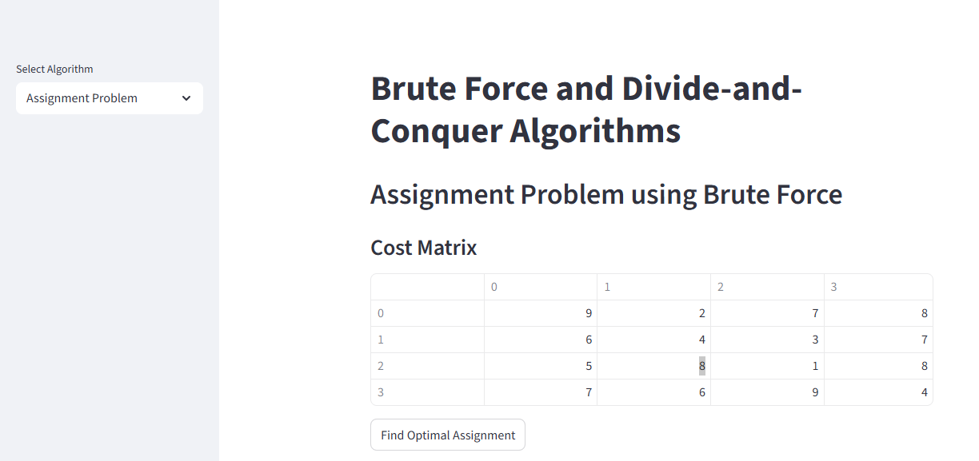

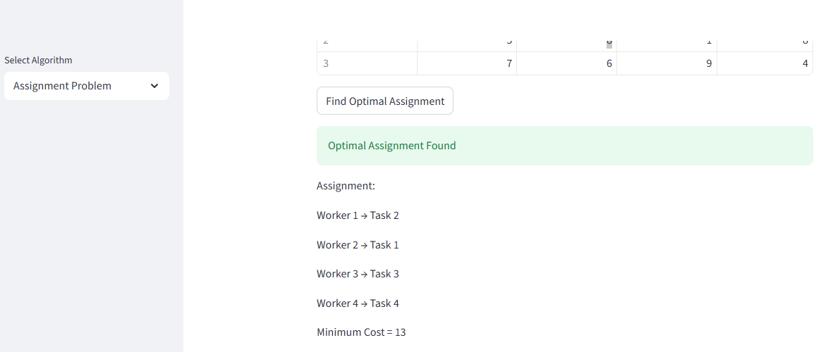

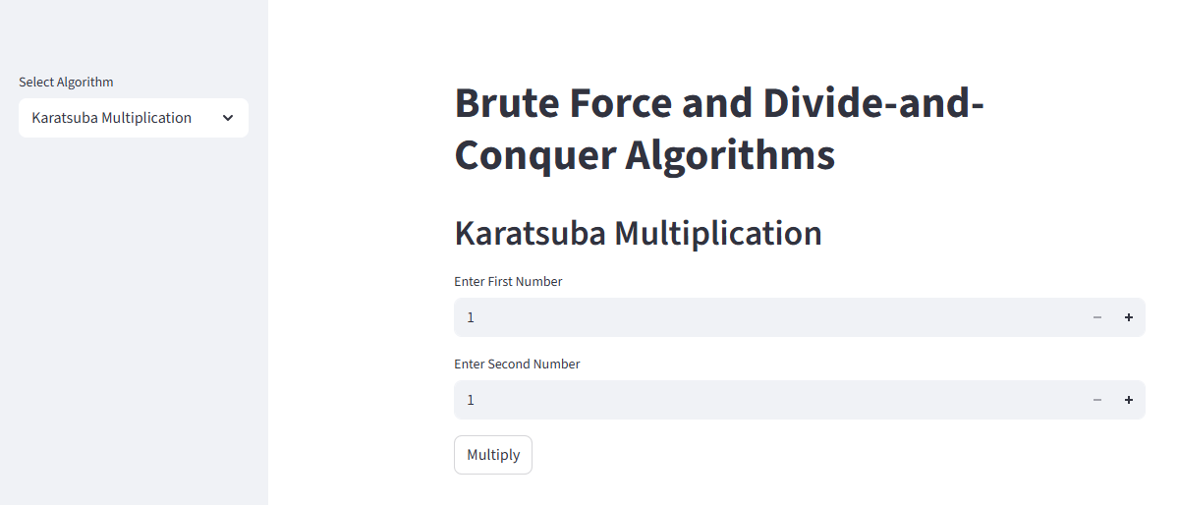

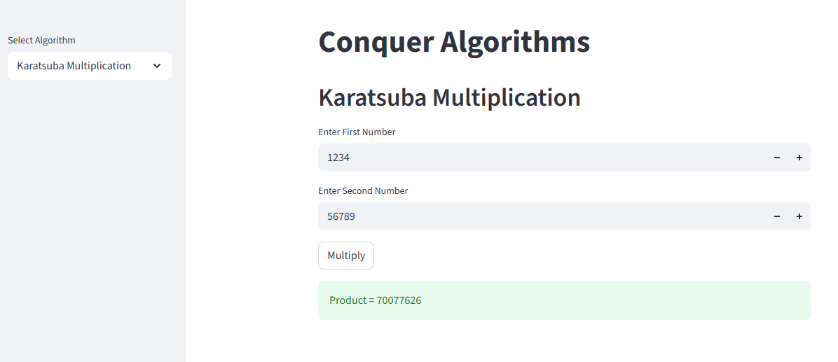

Chapter 9: Performance Metrics
The following metrics are used:

1. Execution Time
Measures total computation time.
Unit:
milliseconds (ms)

2. Time Complexity
Algorithm | Complexity
Brute Force Assignment | O(n!)
Normal Multiplication | O(n²)
Karatsuba Multiplication | O(n^1.585)

3. Memory Usage
Measures RAM consumed during execution.

Chapter 10: Experimental Results

Result 1
Assignment Problem
Assignment | Cost
(1,2,0,3) | 14
The algorithm finds the optimal assignment with minimum cost 14.

Result 2
Karatsuba Multiplication
Input:
x=1234
y=5678
Output:
7006652

Performance Comparison
Number of Digits | Normal Multiplication | Karatsuba
10 | 0.001 sec | 0.002 sec
100 | 0.008 sec | 0.004 sec
1000 | 0.093 sec | 0.032 sec
10000 | 0.954 sec | 0.281 sec
Karatsuba becomes significantly faster for larger integers.

Chapter 11: Advantages
- Brute Force guarantees optimal solutions.
- Karatsuba reduces multiplication complexity.
- Streamlit provides an interactive GUI.
- Algorithms are easy to understand and implement.
- Suitable for scientific and educational applications.

Chapter 12: Applications

Assignment Problem
- Task Scheduling
- Resource Allocation
- Job Assignment
- Transportation Systems

Karatsuba Multiplication
- Cryptography
- Scientific Computing
- Large Integer Arithmetic
- Blockchain Systems

Chapter 13: Conclusion
This micro project presented two important algorithmic paradigms: Brute Force and Divide-and-Conquer. The Assignment Problem was solved optimally using exhaustive search, while Karatsuba Multiplication demonstrated the effectiveness of recursive decomposition for large integer arithmetic. Experimental analysis showed that Karatsuba outperforms conventional multiplication for large inputs. The Streamlit interface enables interactive experimentation and visualization, making the project useful for both academic learning and scientific computing applications.

Future Scope
- Implement Hungarian Algorithm for Assignment Problem.
- Implement Schonhage-Strassen Multiplication.
- Add graphical performance visualization.
- Deploy the application using Streamlit Cloud.
- Extend to distributed and parallel computing.

References
- T. H. Cormen, C. E. Leiserson, R. L. Rivest and C. Stein, Introduction to Algorithms, 4th Edition, MIT Press, 2022.
- A. V. Aho, J. E. Hopcroft and J. D. Ullman, The Design and Analysis of Computer Algorithms, Pearson Education, 2006.
- J. Kleinberg and E. Tardos, Algorithm Design, Pearson Education, 2006.
- A. Karatsuba and Y. Ofman, “Multiplication of Many-Digital Numbers by Automatic Computers,” Proceedings of the USSR Academy of Sciences, vol. 145, no. 2, pp. 293–294, 1962.
- D. E. Knuth, The Art of Computer Programming, Volume 2: Seminumerical Algorithms, 3rd Edition, Addison-Wesley, 1998.

